**Weekly Email**



**Summer Term Issue 163**

**14.09.18**

**To: All Parents**

**Subject: Additional Open Morning Dates**

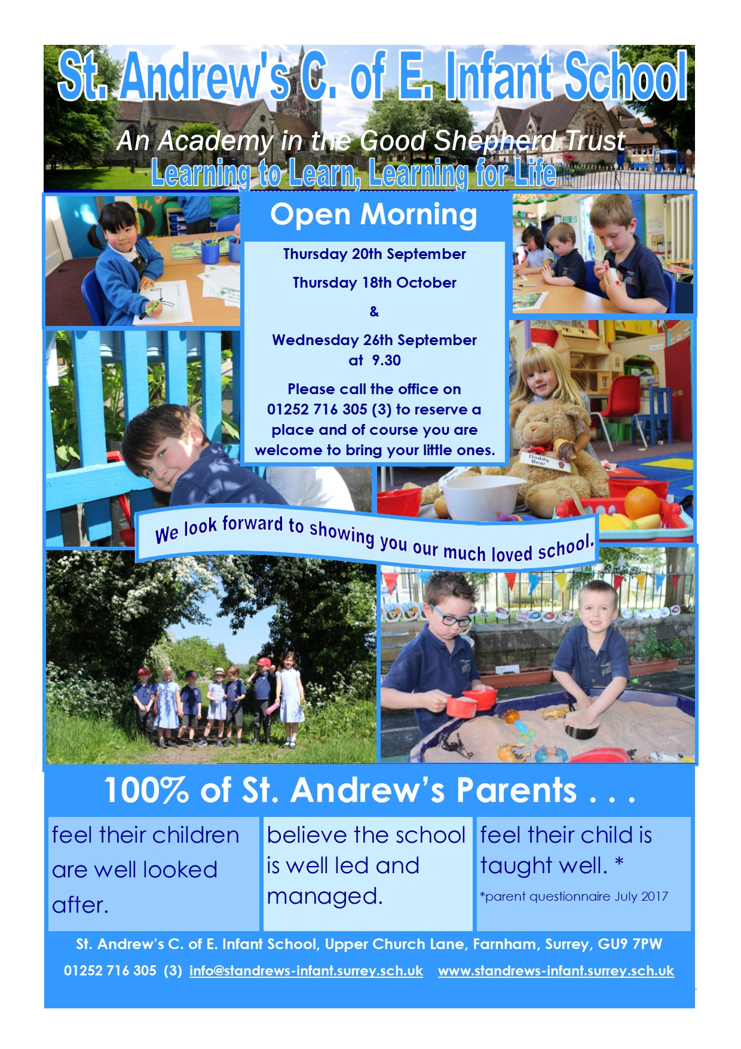

**To: All Parents**

**Subject: Communication at school**

We have a variety of ways of communicating with parents, we hope you will find the links useful.

• Letters/leaflets in your child’s bookbag

• Weekly Email

• Our website: <http://www.standrews-infant.surrey.sch.uk/>

• Class page: <http://www.standrews-infant.surrey.sch.uk/our-learning/class-pages>

• St. Andrew’s School Farnham App here is a link on how to download it to

your phone <https://youtu.be/tq9AOV641uY>

• St. Andrew’s School Hub Facebook [www.facebook.com/groups/1424602944428472](http://www.facebook.com/groups/1424602944428472) (closed group)

• St. Andrew’s School Facebook

[www.facebook.com/StAndrewsSchoolFarnham](http://www.facebook.com/StAndrewsSchoolFarnham)  (public)

• Twitter <https://twitter.com/st_andrews1860>

**To: All Parents**

**Subject: Heritage Open day**

Saturday 15th September 12.00 – 16.00 (the school is open to the public but this would be a perfect way for your child to show you, grandparents etc. his/her school)

**To: All Parents**

**Subject: School Socials**



**Back to School Socials - 2 chances to meet up for Owl and Robin parents**

Some chances to catch up after the summer and welcome the new reception parents.

Friday 21st September – Come out for drinks, we have tables reserved by the Piano in the Wheatsheaf pub from 8pm

Monday 24th September – Coffee morning at the back of St Andrews church, younger siblings welcome (there will by toys) 9 – 9.45.

Hope to see you at one or both – The Owl Class reps

**To: All Parents**

**Subject: Admission 2019**



**To: All Parents**

**Subject: Football**

Saturday morning Football 10.30 - 11.30 at Potters Gate

Fun, friendly kickaround - age 6 - 9 years, £2 a week

Email [tris@bigpotato.co.uk](mailto:tris@bigpotato.co.uk) for more info.

**To: All Parents**

**Subject: Farnham Festival fundraiser**



**To: All Parents**

**Subject: Parenting Course**



|  |  |  |  |
| --- | --- | --- | --- |
| **All** | 15.9.18 | 12.00 – 16.00 | Heritage Open Day – All welcome |
| **All** | 17.9.18 | 15.00-16.00 | No Art Club |
| **All Prospective Parents** | 20.9.18 | 9.30 | Open Morning – Please call the office on 01252 716 305 (3) to reserve a place. |
| **All Prospective Parents** | 26.9.18 | 9.30 | Open Morning – Please call the office on 01252 716 305 (3) to reserve a place. |
| **All pupils** | 27.9.18 | AM | Photographer to take Individual pictures of pupils. |
| **Year 2 pupils** | 3.10.18 | 16.00 – 17.00 | Multi Skills at Weydon School |
| **Year 1 pupils** | 17.10.18 | 16.00 – 17.00 | Multi Skills at Weydon School |
| **All Prospective Parents** | 18.10.18 | 9.30 | Open Morning – Please call the office on 01252 716 305 (3) to reserve a place. |
| **All** | 19.10.18 | - | Last School day –  school closes usual time |
| **All** | 20.10.18 – 28.10.18 | - | Half Term |
| **All** | 29.10.18 | 8.40 | School re-opens |
| **All** | 16.11.18 | Am | Nasal Flu session |
| **All** | 19.12.18 | - | Last School day – school closes at 13.30 |
| **All** | 20.12.18-2.1.19 | - | Christmas Holidays |
| **All** | 3.1.19 | 8.40 | School re-opens |
| **Year 2 pupils** | 25.1.19 | 16.00 – 17.00 | Ball Skills at William Cobbett School |
| **All** | 15.2.19 | - | Last School day –  school closes usual time |
| **All** | 16.2.19 – 24.2.19 | - | Half Term |
| **All** | 25.2.19 | 8.40 | School re-opens |
| **Year 1 pupils** | 13.3.19 | 16.00 – 17.00 | Ball Skills at South Farnham Junior School |
| **Year 2** | 27.3.19 &28.3.19 | 17.00 | Farnham Festival Performance - Year 2 – Farnham Maltings |
| **All** | 5.4.19 | - | Last School day – school closes at 13.30 |
| **All** | 6.4.19 - 22.4.19 | - | Easter Holidays |
| **All** | 23.4.19 | 8.40 | School re-opens |
| **All** | 24.5.19 | - | Last School day –  school closes usual time |
| **All** | 25.5.19 – 2.6.19 | - | Half Term |
| **All** | 3.6.19 | 8.40 | School re-opens |
| **Year 2 pupils** | 4.6.19 | 16.00 – 17.00 | Athletics at Potters Gate School |
| **All** | 14.6.19 – 16.6.19 | - | St. Andrew’s Camping weekend |
| **Year 1 pupils** | 19.6.19 | 16.00 – 17.00 | Athletics at St. Polycarps School |
| **Year R pupils** | 26.6.19 | 16.00 – 17.00 | Multi Skills at Highfield South Farnham School |
| Y2 | 5.7.19 | am | Bike ability training (bring scooter, tricycle or bicycle (with or without stabilisers). + helmet if you have one.  Pls park bikes/scooters near the carved chair in the top playground |
| **All** | 19.7.19 | - | Last School day – school closes at 13.30 |
| **All Pupils** | 22.7.19 – 24.7.19 | All day | Inset days – school closed for pupils |
| **All** | 25.7.19-3.9.19 | - | Summer Holidays |